Record producers

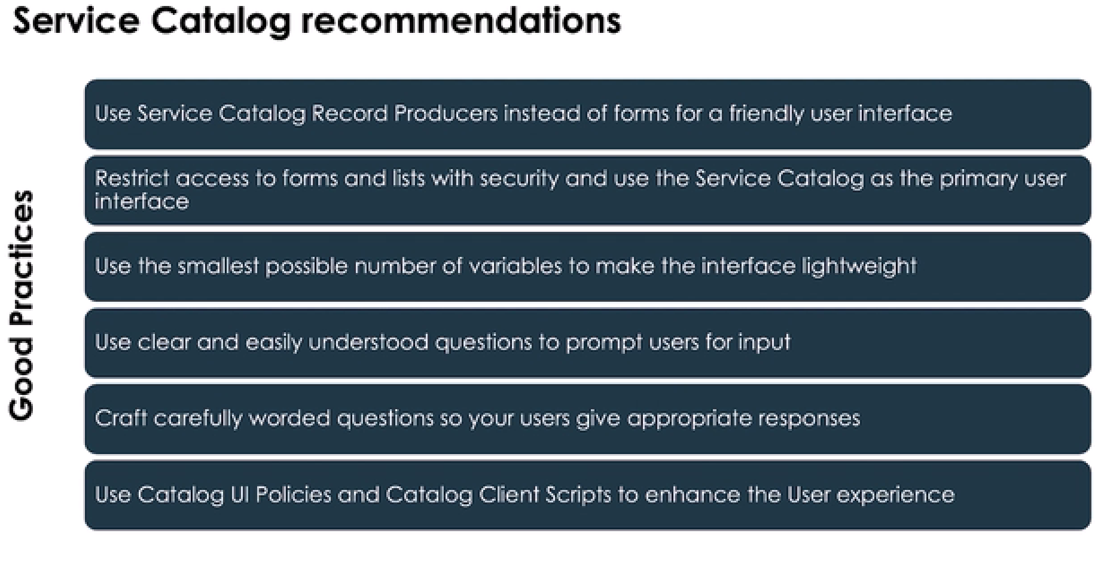

# Properties –

Created by developers (usually during the design phase) to make changes later by non technical people sometimes.

So they don’t need to go change the codes.

>>Change properties

## Script include

Use api name if you are using the script include outside the scope

Integration –

Respresentational State Transfer

Modify url

>>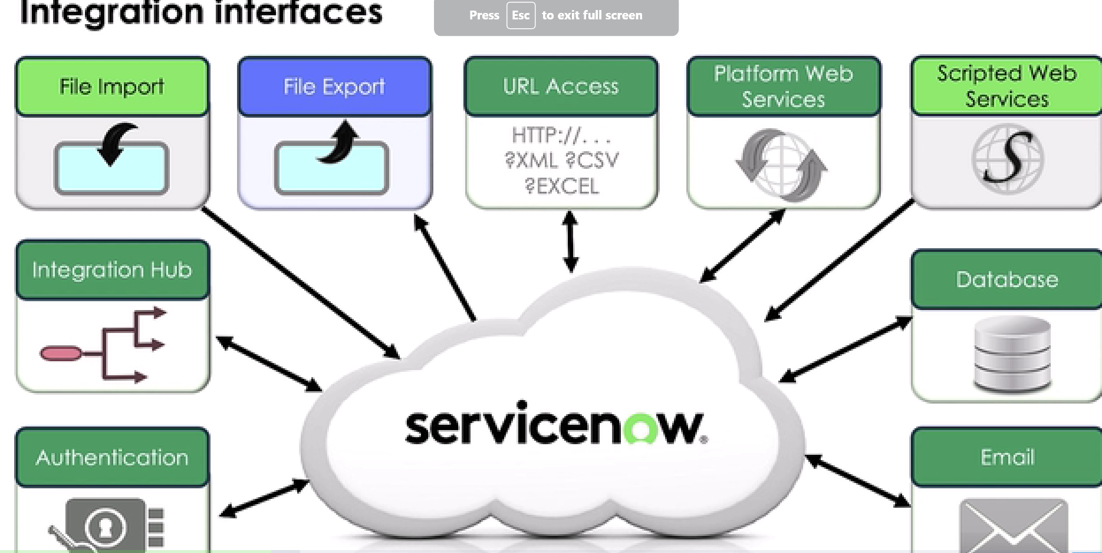

Importing via update sets

Everything basically in servicenow is a table which is >> a record at the end, right? So basically each record is a javascript object which is gliderecord.

Web services – conversation b/w 2 lonely softwares, ie a way to communicate

web services consumer

web services provider

Rest methods

Crud methods

Get – read/fetch data

Post – insert/create

Updates –

Put- complete override of post

Patch – partial update

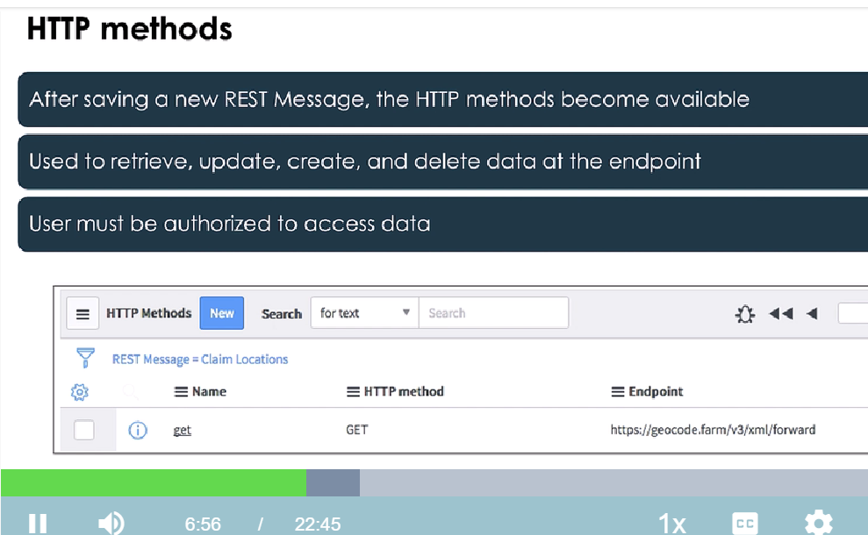

# Outbound Rest message

Number >> user records>>pins on location

Step 1. Users with locations values

Step2. Interacting with other map by creating outbound rest map

Step3. Position app is free (positionstack in browser)

Step4. We are doing a forward lookup. >>read the documentation >>

Step 4. Check the query you need to write in the API REQUEST

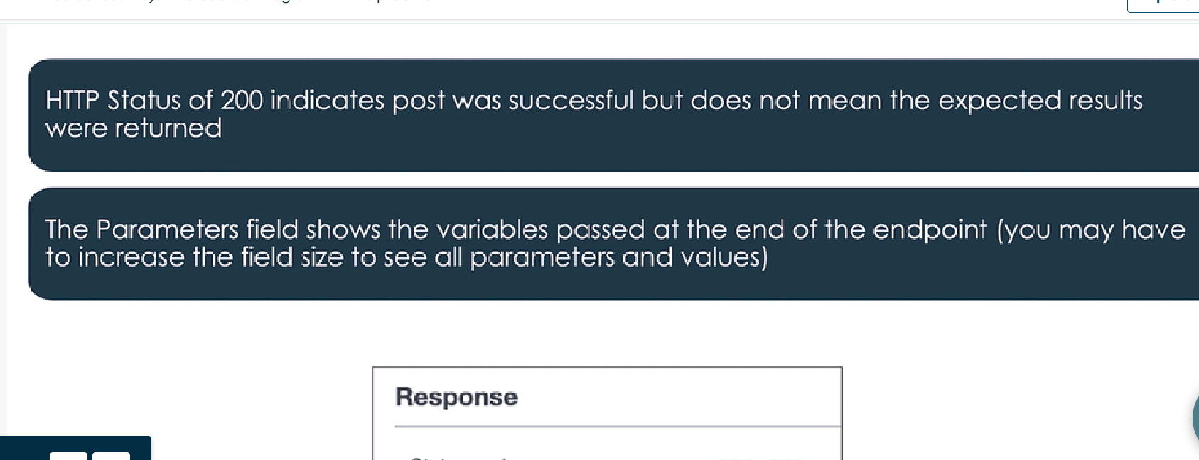

Rest Explorer API

Endpoint - Snow url/api/now/table/system name of your target table

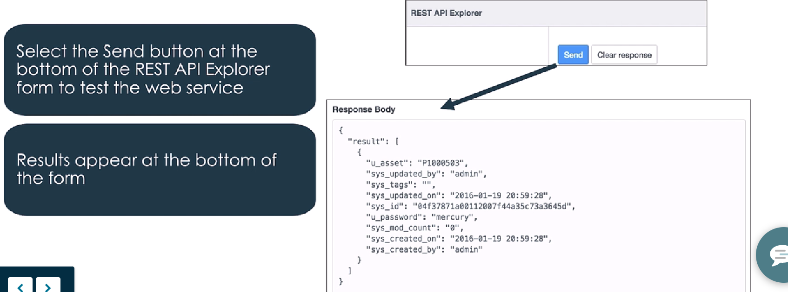

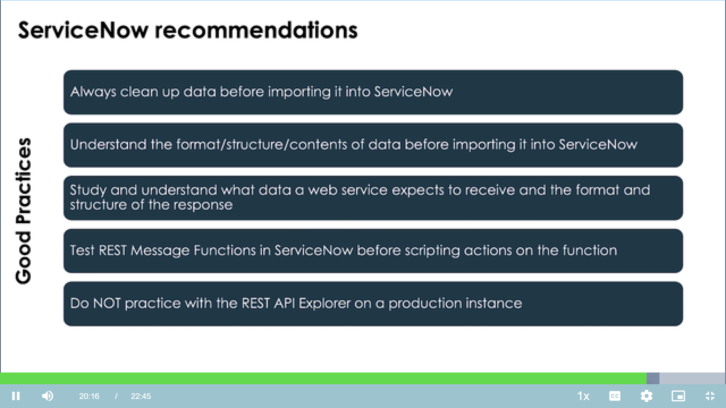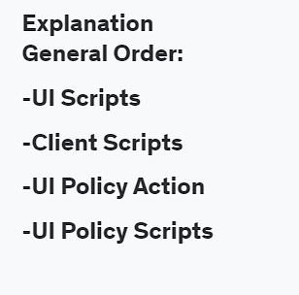

For record producers it should be producer.variablename. For catalog items it will be current.variablename.

The source control operation used to store local changes on an instance for later application is called a(n). stash

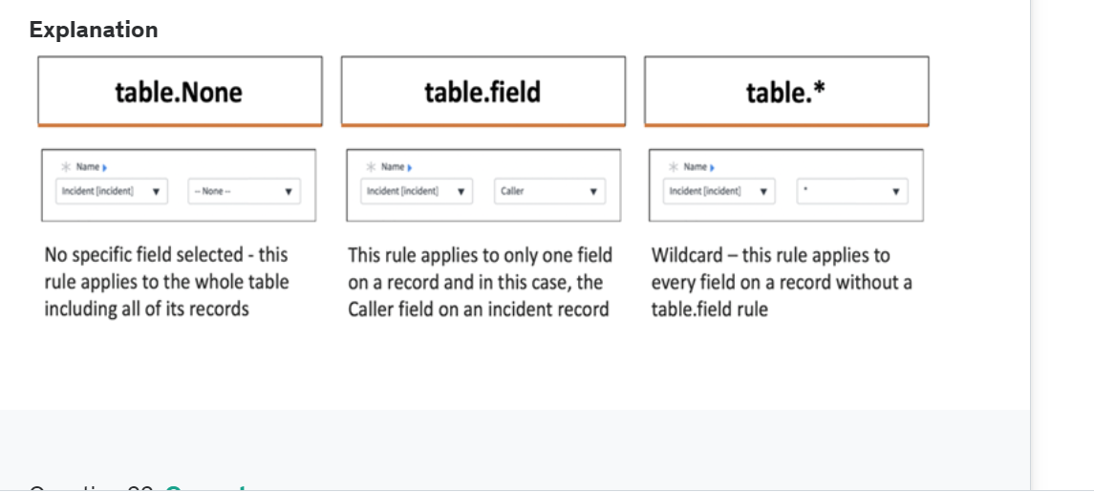

1. code search feature - search for the code in a br/all application/in your application

2. Which protects applications by identifying and restricting access to application files and data?

++++++

very important –

watch this youtube video – All questions were from herehttps://youtu.be/W4NdUuOdA8g?si=iFIDXRFDXclivets

Try this udemy mock test - [Course: ServiceNow Certified Application Developer I CAD I Mar 2024 | Udemy Business](https://deloittedevelopment.udemy.com/course/servicenow-certified-application-developer-i-cad-i-sept-2022/learn/quiz/5666618#overview)